Eugene High School Songs, Cheers, and Yells-Circa 1954-1964

The following recalled by Norma Jane (Sestak) Spalding and Glenda (Gray) Hardin with photos courtesy of Liz (Ekstam) Ray. All are Class of 1955

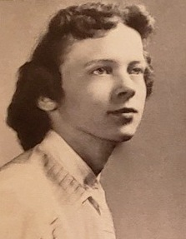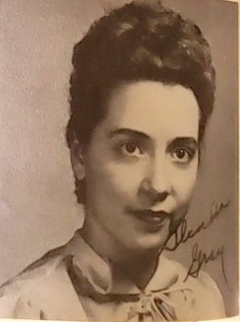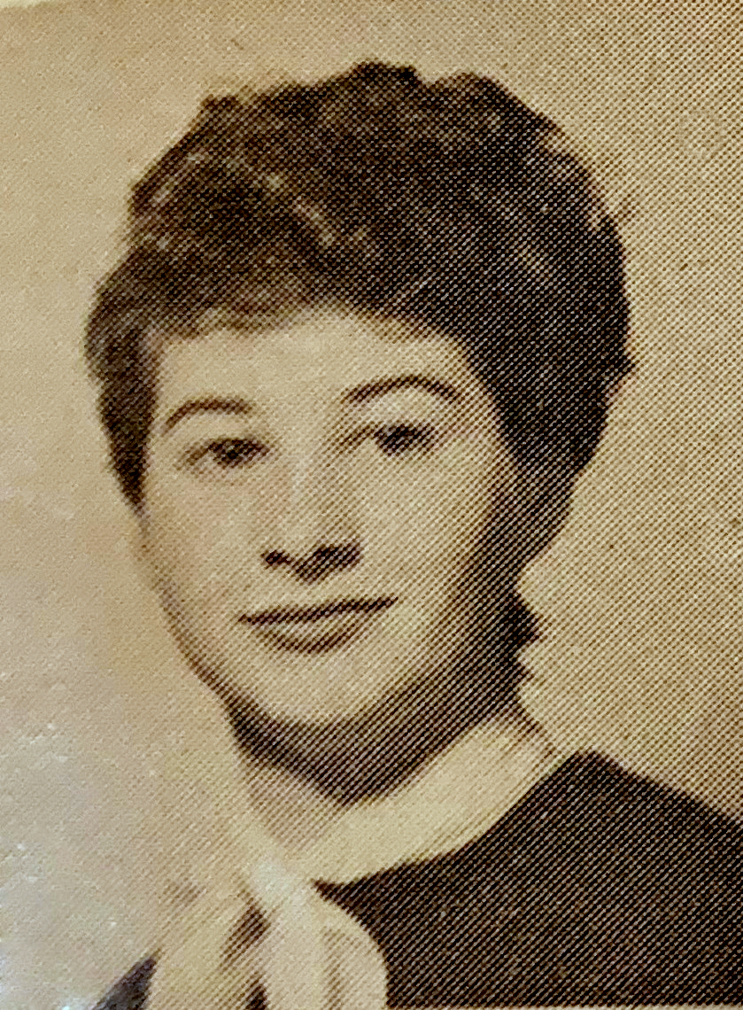
Norma Sestak Glenda Gray Elizabeth Ekstam

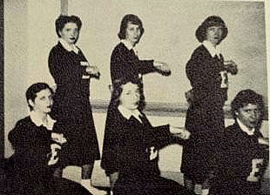

Eugene Cheerleaders, 1954

Back Row, L-R: Glenda Gray, Judy Spalding, Norma Sestak;
Front Row, L-R Marilyn Johnston, Joyce Tellman, and Mary Lee Reavis.
(Half the cheerleaders, cupped hands over mouths)
“Someone’s in the crowd yelling!”

(Other cheerleaders reply)
“Who are you gonna yell for?”

(all cheerleaders in unison)
“Kelan, that’s who!
Rah,, Rah, Rah, Rah!!”

(Repeat the yell for each player on the first team)

“Go back! Go back!
Go back to the woods!
You haven’t got the rhythm,
And you haven’t got the jazz!!
You haven’t got the team that Eugene has!!”

“Grandma's bonnet!, (Cheerleaders facing the audience and putting our hands to our head like a bonnet)

“Grandma's bustle!, (We turned around and flipped up the back of our skirt toward the audience)

“Come on team—Let’s Hustle!” (we remained with our back to the audience and facing the team, motioning with our arms to "come on")

“A-C-T----I-O-N, A-C-T----I-O-N, A-C-T----I-O-N.”
(Words spelled out)
“Action, boys, Action!”

“One for the money,
Two for the show,
Three to get ready,
Now go team go!!!”

The following recalled by Alan Wright, Class of 1964

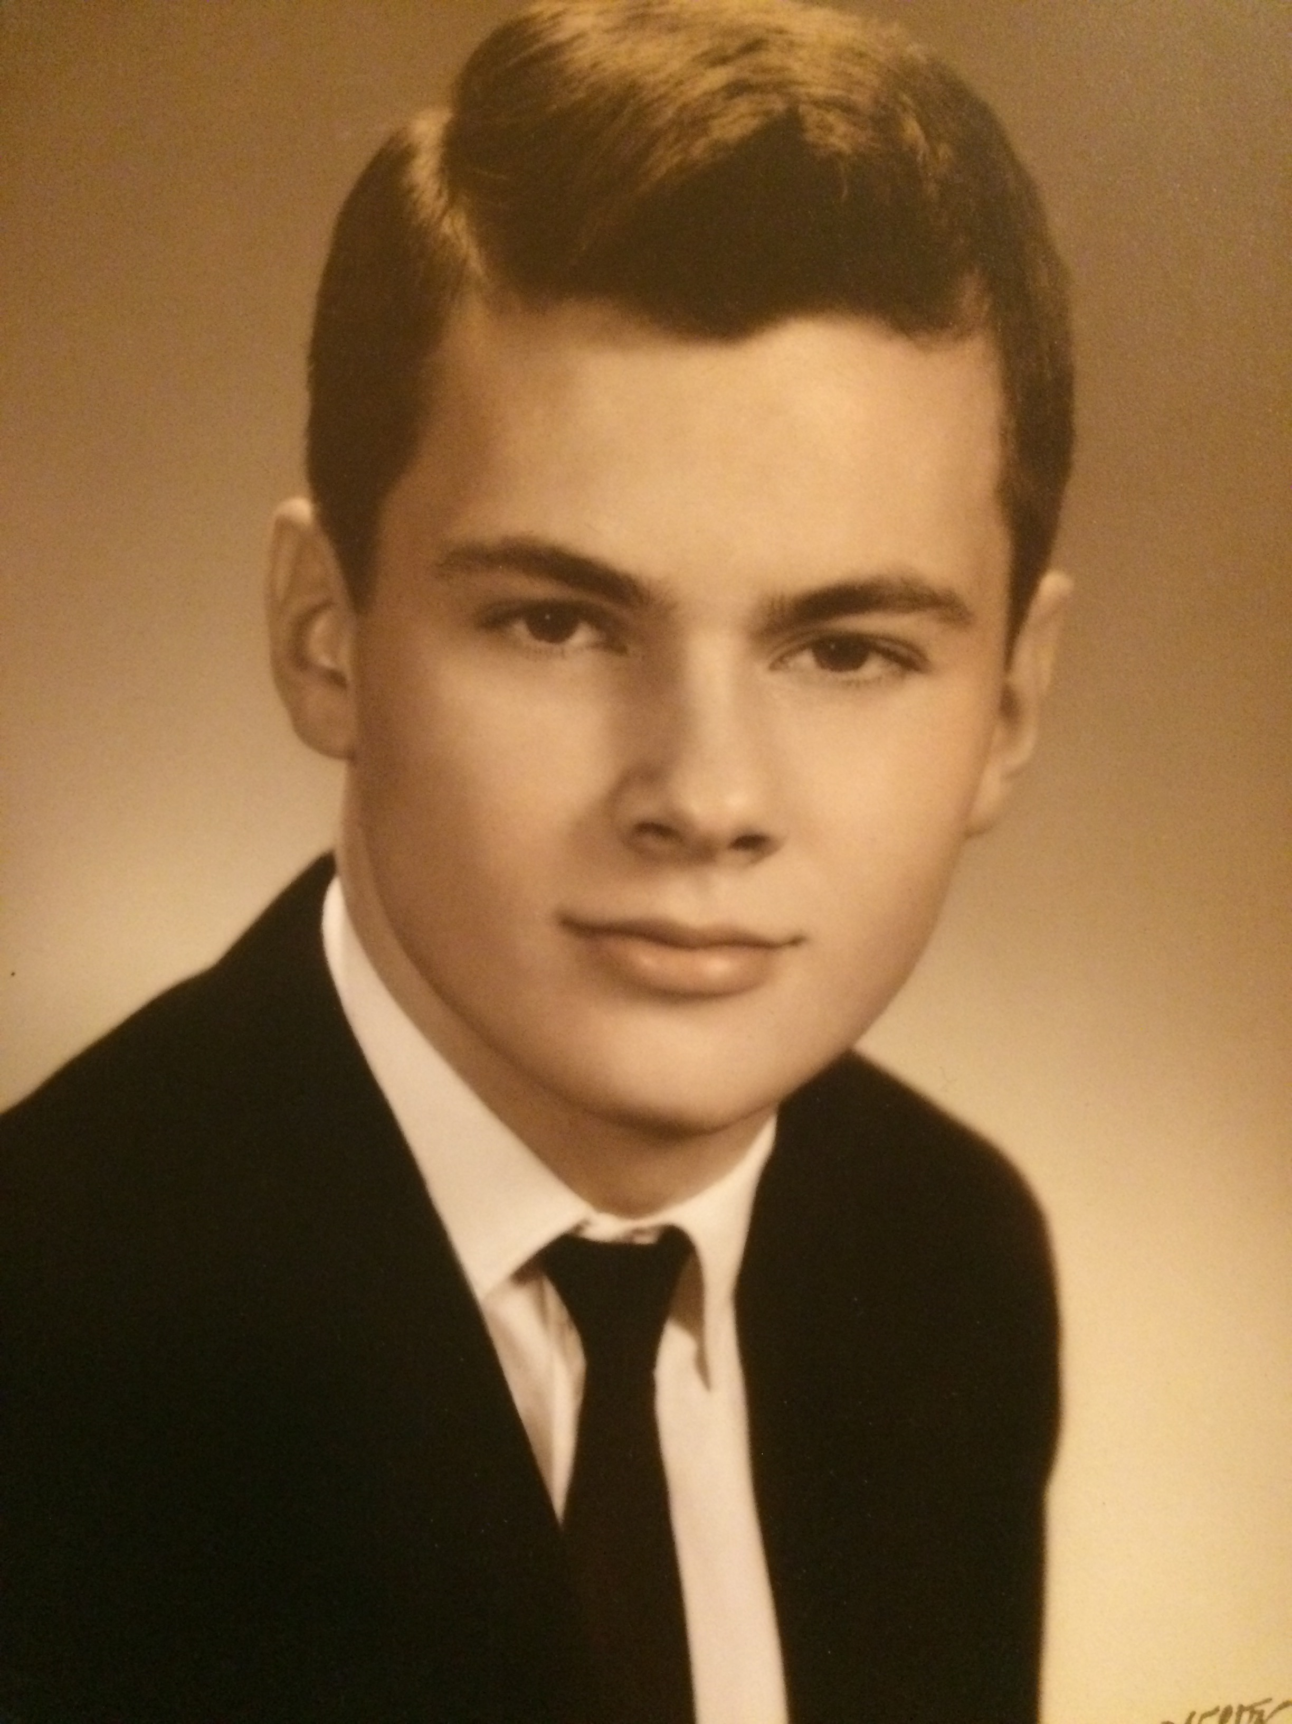
Alan Wright

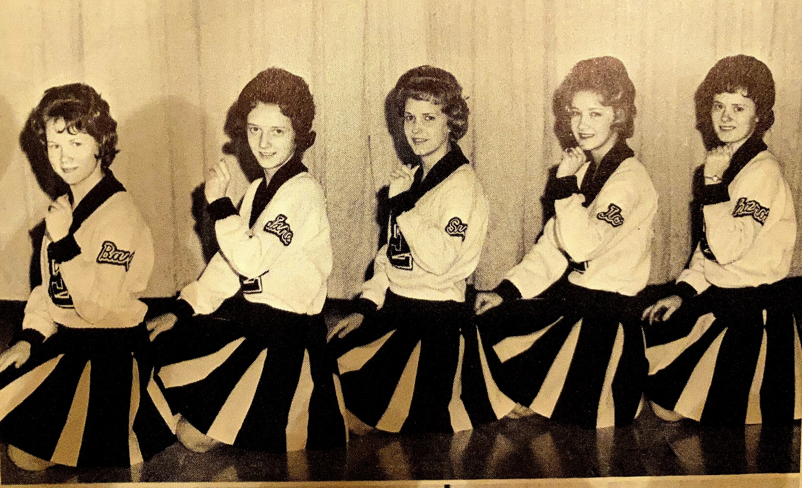
Eugene Cheerleaders, 1964
L-R: Barbara Wilson, Jane Baysinger, Susie Schwaller, Paula Binkley, Sharon Hart

School Song

“Sing praises to our high school,
Keep her honor shining bright.
We are loyal to our colors,
We revere the black and white.
We must confess that our success,
Has raised our courage high!
O’er the true and brave,
May our banner wave,
Keep faith in Eugene High.”

(followed by)
Rah, Rah, Rah, Rah
Rah, Rah, Rah, Rah
Eugene! Eugene!”

(A Song)

“Eugene will shine tonight,
Eugene will shine!
We'll shine in glory bright,
All down the line!
We're all dressed up tonight
And don't we look fine?
When the sun goes down (stomp,stomp)
And the moon goes up (stomp,stomp)
Eugene will shine!”
(followed by)
Rah, Rah, Rah, Rah
Rah, Rah, Rah, Rah
Eugene! Eugene!”

(A song)

“…And when we get there you'll remember,
Saturday night at a quarter of eight (stomp, stomp)
Now, don't you be late!
Gotta be there when that ball starts movin’”

(There was a beginning or following verse---all sung to the tune of “Darktown Strutter’s Ball,” written by Shelton Brooks and recorded by Fats Waller, 1939)

(A song)

“Well, the Eugene Boys that are on the team
Are full of pep right up to the last,
(words missing) XXXXXXXXXXXXXXXXXXXXX
XXXXXXXXXXXXXXXXXXXXX
XXXXXXXXXXXX…..Eugene High!”
(Rah, Rahs)

(While on defense)

“Hey, hey, take it away,
Eugene, take that ball away!
Hey, hey, take it away,
Eugene, take that ball away!”

(In the closing minutes or seconds of a very close game)

“Two bits, four bits, six bits—a dollar,
All for Eugene, Stand up and holler!”

(Cheerleaders cupped hands around mouths)

“Ship ahoy, ship a-hoy
We’re from Eugene, oh-boy!
You may be rough,
You may be tough,
But we’re the team that’s got the stuff!
(followed by)
Rah Rah Rah Rah!
Rah Rah Rah Rah!
Eugene! Eugene!”

(Eugene player scores—One Cheerleader leads, while running down the floor---ending with a jump)

“Yay, Gary,
Yay, Gretlein,
Yay, Yay,
Gary Gretlein!”

(A song to kill time on bus to the game)

“One hundred bottles of beer on the wall,
One hundred bottles of beer,
You take one down and pass it around
And you have ninety-nine bottles of beer on the wall!

(repeat 99 times)

(Another bus song, sung to the tune of the Notre Dame fight song.
All in jest of course!)

“Hail, hail, to old Eugene High
You bring the whiskey, I’ll bring the rye,
Send the Freshmen out for gin
And don’t let a single Sophomore in!

“We never stagger, we never fall
We sober up on wood alcohol,
While the loyal fac-ul-tee
Lies drunk on the old gym floor!

